Laser Skirmish Permission Form
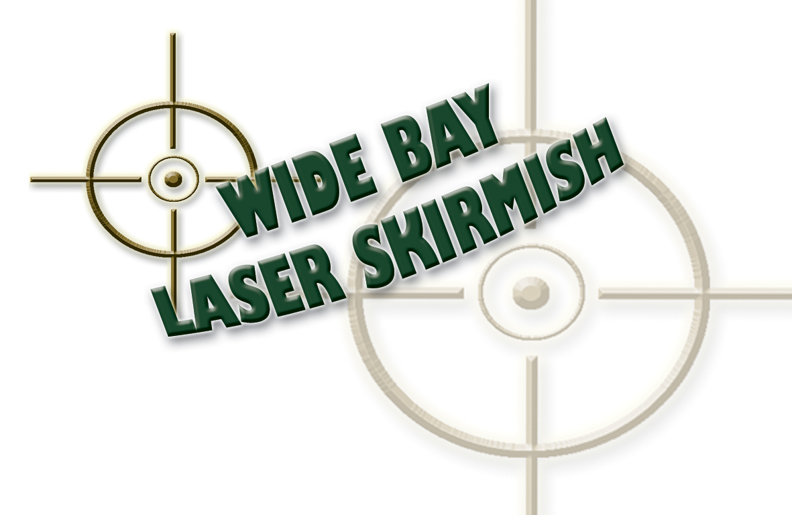
Hand this completed Permission Form, Release
& Indemnity Form to Mission Major PRIOR TO PLAY
Check our website for your closest field
Phone: 4126 3222 Facsimile: 4126 3233
Email: info@widebaylaserskirmish.com.au Internet: www.widebaylaserskirmish.com.au
 | In this form: “Wide Bay Laser Skirmish” means the activity of laser skirmishing at various venues and includes the use of Laser Skirmish guns, mines and other accessories and equipment and facilities which relate in any way to the activity of laser skirmishing. Further, “other activities” means anything except laser skirmishing which occurs at a venue and includes (without limitation) the use of all equipment, services, land, buildings, carparks, paths, at the venue (except when skirmishing.) In exchange for Wide Bay Laser Skirmish (with its employees, agents, licenses, contractors, subcontractors, subsidiaries, related or associated companies, associates, and assignees) agreeing to let me take part in laser skirmish. So, I…
 | First Name: |  |  |  |  |  |  |  |  |  |  |  |  |  |  | Surname
 | Address:
 | Suburb / City:
 | State:
 | Post Code: |  |  |  |  |  |  |  | Email
Telephone No:  Including Area Code |  |  |  |  |  |  |  |  |  |  |  |  |  |  |  |  |  |  |  |  | Fax No:
Invited by Corporate/Social Group name:
Sex: |  |  |  |  |  | Male |  |  | Female |  |  |  |  | Date of Birth (dd/mm/yy) |  |  |  |  |  |  |  |  |  |  |  |  |  | and now aged |  |  |  |  |  |  |  |  |  |  | years
 | Favourite Movie: |  |  |  |  |  |  |  |  |  |  |  |  |  |  |  |  |  |  | Favourite Game:
Preferred Call Sign: |  |  |  |  |  |  |  |  |  |  |  |  |  |  |  |  |  |  |  | Clan Name:
How did you find us? |  |  |  |  | Radio |  |  |  | Friend |  |  |  |  |  | Work/Social Event |  |  |  |  | White/Yellow Pages |  |  |  |  |  | TV |  | Other pls specify →
 |  |  |  |  | Promotion |  |  |  | Sign |  |  |  |  |  | Newspaper |  |  |  |  | Inflatables Event eg Fete |  |  |  |  | Web – what search term? →
 | Myself and my executors, administrators and assigns acknowledge and agree that:
  - THE PARTICIPANT COVENANTS AND AGREES WITH THE FOLLOWING RULES, TERMS AND CONDITIONS:
The participant agrees to abide by the rules of Laser Skirmish at all times when present at the Venue.
  - No projectiles are to be thrown, kicked or otherwise made airborne by participants.
  - No participant shall engage in:-
- Skylarking or reckless behaviour or foolish behaviour; or  - Any other behaviour likely to cause injury to themselves or other participants; or to employees or agents of Wide Bay Laser Skirmish; or | - Any other behaviour which Wide Bay Laser Skirmish deems in its absolute discretion to be unacceptable.
  - Wide Bay Laser Skirmish may require any participant engaging in unacceptable behaviour to leave the Venue.
  - Each participant must remain within the designated boundaries of the Venue at all times.
  - Each participant will be required to wear the following:-
- Long trousers (covering ankles) and Enclosed shoes; and  - Hats and/or Caps provided by Wide Bay Laser Skirmish; | - All other safety devices that Wide Bay Laser Skirmish may require the participant to wear.
  - Any participant who is unable or refuses to comply with rule (e) will not be permitted to participate in Laser Skirmish.
  - All participants must follow the directives of Wide Bay Laser Skirmish at all times.
  - Any participant injured, or observing another participant to be injured, shall immediately notify Wide Bay Laser Skirmish staff of the incident.
  - By signing below, I hereby authorise Wide Bay Laser Skirmish to send me newsletters and special product officers to my email address supplied. I further understand that I can terminate the transmission of such materials by return email by typing the word “Unsubscribe” in the subject line.
  - RELEASE & DISCHARGE

The Participant releases, discharges, waives and forever holds harmless Wide Bay Laser Skirmish from All Claims for Any Loss sustained by the Participant whether caused by Wide Bay Laser Skirmish’s negligent act or wilful act or omission, breach of contract, breach of statutory duty or otherwise in connection with Laser Skirmish. The participant agrees to Wide Bay Laser Skirmish taking photographs, film and other images while participants are at the venue and to develop, print, reproduce and use them royalty free for any purpose (including commercial advertising).
  - INDEMNITY

The Participant indemnifies Wide Bay Laser Skirmish against All Claims for Any Loss sustained by the Participant whether caused by Wide Bay Laser Skirmish’s negligent act or wilful act or omission, breach of contract, breach of statutory duty or otherwise in connection with Wide Bay Laser Skirmish.

WARRANTY AS TO AGE

By personally executing this Deed, the Participant warrants that he or she is at least of eighteen (18) years of age. Where this Deed is executed by a parent, guardian or other person for and on behalf of the Participant, the person so executing warrants that he or she has authority to do so and that such parent, guardian or other person agrees to indemnify Wide Bay Laser Skirmish in terms of the indemnity contained in clause 1.3 hereof.

BAR TO ACTION
The Participant agrees that this Deed may be pleaded as a bar to any action, suit or proceedings taken at any time by the Participant against Wide Bay Laser Skirmish arising out of or as a consequence of Laser Skirmish or any incidental activities.

CONFIDENTIALITY
The Participant must keep the terms of this Deed strictly confidential and no disclosure of the terms of this Deed is to be made by the Participant other than for the purpose of obtaining legal advice.

BINDING ON SUCCESSORS
This Deed binds the heirs, administrators, executors, personal representatives, dependants (if any) and successors of the Participant and enures for the benefit of Wide Bay Laser Skirmish and its successors and assigns.

PRIVACY
Wide Bay Laser Skirmish collects information from you for the primary purpose of providing quality outdoor Laser Skirmish entertainment. We require you to provide us with details so that we may properly attend to your needs. This means we will use the info you provide in the following ways: administrative purposes, billing purposes (if required), disclosure for research and quality assurance activities to improve entertainment services, and if needed, emergency situations whereby staff/hospitals require access to a participants records for appropriate purposes.

DEFINITIONS
In this Deed unless inconsistent with the context or subject matter:
“All Claims” means all claims, actions, suits, demands, damages, interest and costs arising out of or as a consequence of Wide Bay Laser Skirmish, including any incidental activity;
“Any Loss” means any loss, damage or injury to person (including the Participant) or property including but not limited to:- (a) Any damage or injury occasioned to a participant, howsoever, by:-
- Any logs, trees and branches or any part thereof;  - Any rocks, falling boulders or stones;  - Any rivers, creeks, streams or any other body of water existing at a Wide Bay Laser Skirmish Venue;  - Any snakes, spiders or any other wildlife whatsoever; | - Other participants;  - Any equipment supplied to the Participant by Wide Bay Laser Skirmish in connection with Laser Skirmish;  - or otherwise arising out of the Participant's involvement in Laser Skirmish.
    - Any damage or injury occasioned to a Participant as a result of a Participant:-
- Slipping on rocks, boulders, logs, trees, land or any other substance; and/or | - Falling over; and/or  - Colliding with another participant
whether caused by:-
- Negligence; or  - Accident; or  - Another participant; or | - Flora or fauna; or  - However otherwise caused.
“Laser Skirmish” means the outdoor action role play combat game run by RP Kay trading as Wide Bay Laser Skirmish and/or Laser Tag
“Laser Skirmish Venue” means the location at which Laser Skirmish/Laser Tag is being convened;
“Participant” means their FULL NAME, and ADDRESS as per section one of this form.
“Wide Bay Laser Skirmish” means a business of Russell Phillip Kay – ABN 48 028 296 919 of 19 Tyndall Street Apple Tree Creek Q 4660 and its agencies, suppliers, distributors, servants, employees, agents, representatives, directors, and officers.

SIGNATURES
I promise that the information about me/participant in this form is correct. I have read and understand everything in this form. Executed as a deed

SIGN HERE IF YOU ARE OVER 18:-
SIGNED SEALED AND DELIVERED by  ________________________________________  (PARTICIPANT’S FULL NAME)  Dated: | )  )  ) Signature of Participant  Signature of Witness of the Participant

GUARDIAN SIGN HERE IF THE PARTICIPANT IS UNDER 18:-
SIGNED SEALED AND DELIVERED by  ________________________________________  PRINT PARTICIPANT’S FULL NAME  ________________________________________  (SIGNEE’S FULL NAME)  ________________________________________  (if signing on behalf of Participant, print relationship to Participant)  who warrants that he or she has authority to sign this Discharge, Release & Indemnity on behalf of the Participant & agrees to indemnify Wide Bay Laser Skirmish in accordance with the indemnities in this agreement. | )  )  ) Signature of Guardian  )  )  Signature of Witness of the Guardian  Dated:

